Wagner et al (2004)

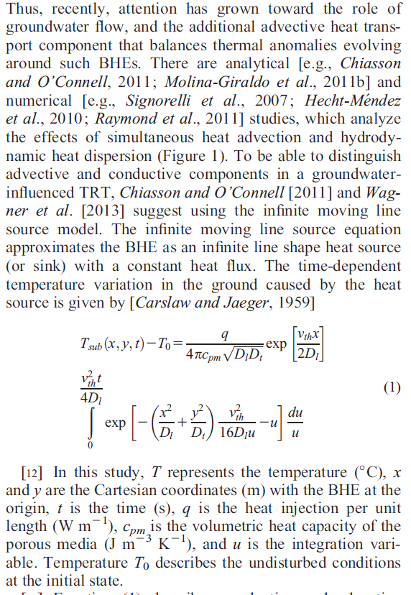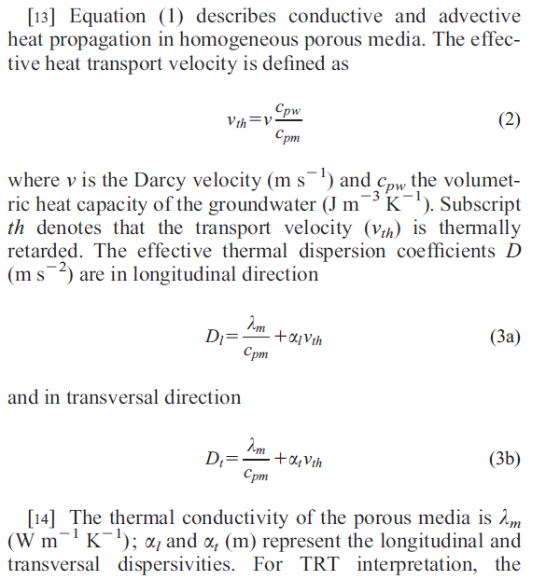

We ignore Rb, the heat recovery coefficient, which relates to the borehole wall temperature to the heat carrier fluid temperature (Sutton et al., 2002)

